Assignment 8

Question 1 = Assume each salesperson has a commission of 12%.Write a query on the orders table that will produce the order number, the salesperson number , and the amount of the sales person’s comminsion for that order.

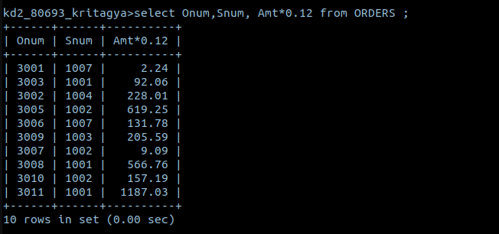
Question 2 = Write a query on the customers table that will find the highest rating in each city. Put the output in this form:
For the city (City), the highest rating is : (rating).
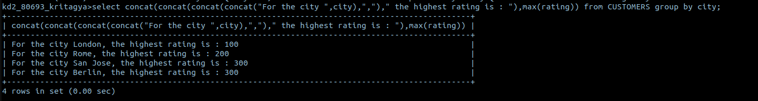

Question 3. Write a query that lists customers in descending order of rating. Output the rating field first, followed by the customer’s name and number.
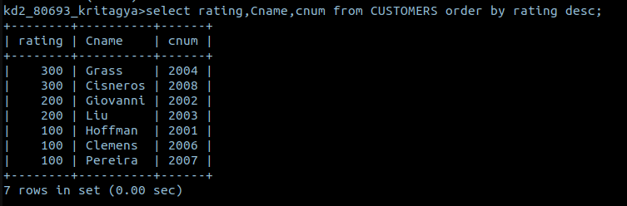
Question 4. Write a query that totals the orders for each day and places the results in decending order

